Running Instructions

Contents

Requirements 2

Installing Prophecy 13 2

Enabling IIS 3

Registering ASP.NET 4.5 with the IIS Web Server 3

Building Code 4

Configuring IIS 5

Configuring Prophecy 13 6

Quick Checks 7

Test Call 7

# Requirements

List of required hardware:

1. Laptop or desktop computer running Windows XP or above

List of required software:

1. SIP and VXML interpreter software
   1. [Voxeo Prophecy 1](http://www.voxeo.com/prophecy/home.jsp)3
2. [Microsoft Visual Studio 2010](http://www.microsoft.com/en-us/download/details.aspx?id=23691) or 2012
3. [.NET Framework 4](http://msdn.microsoft.com/en-us/netframework/aa569263.aspx) or higher
4. [IIS 7.5](http://www.microsoft.com/download/en/details.aspx?id=1038)
5. Microsoft SQL Server

Other requirements:

1. Administrator privilege on the machine

# Installing Prophecy 13

1. Download 32 bit or 64 bit [Prophecy 1](http://www.voxeo.com/prophecy)3 installer as per the Windows OS version.
2. Click on the Installer and follow the instructions.
3. Prophecy 13 should be installed in **Server mode**.

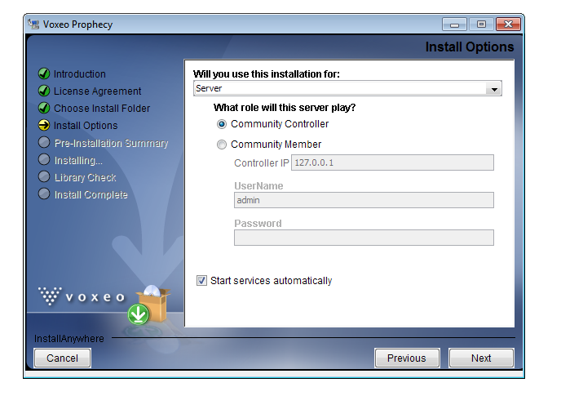

1. Once the installation completes, all services of Prophecy should be running. You can check the status of the Prophecy services by clicking **Voxeo Prophecy icon** ( ) and then hover the mouse on **Start** option. There should be right tick mark in front of all services. Usually Prophecy takes some time (2-5 minutes, depending on the speed of your machine ) to start all services

# Enabling IIS

1. Go to **Start** -> **Control Panel** -> **Programs**
2. In **Programs and Features**, Open **Turn Windows Features on or off**
3. In **Windows Features** window, find **Internet Information Services** andEnable **Internet Information Services**
4. Expand **Internet Information Services** -> Expand **World Wide Web Services** -> Expand **Application Development Features** -> Enable **ASP.NET, .NET Extensibility, ISAPI Extensions, ISAPI Filters**. Click **OK**

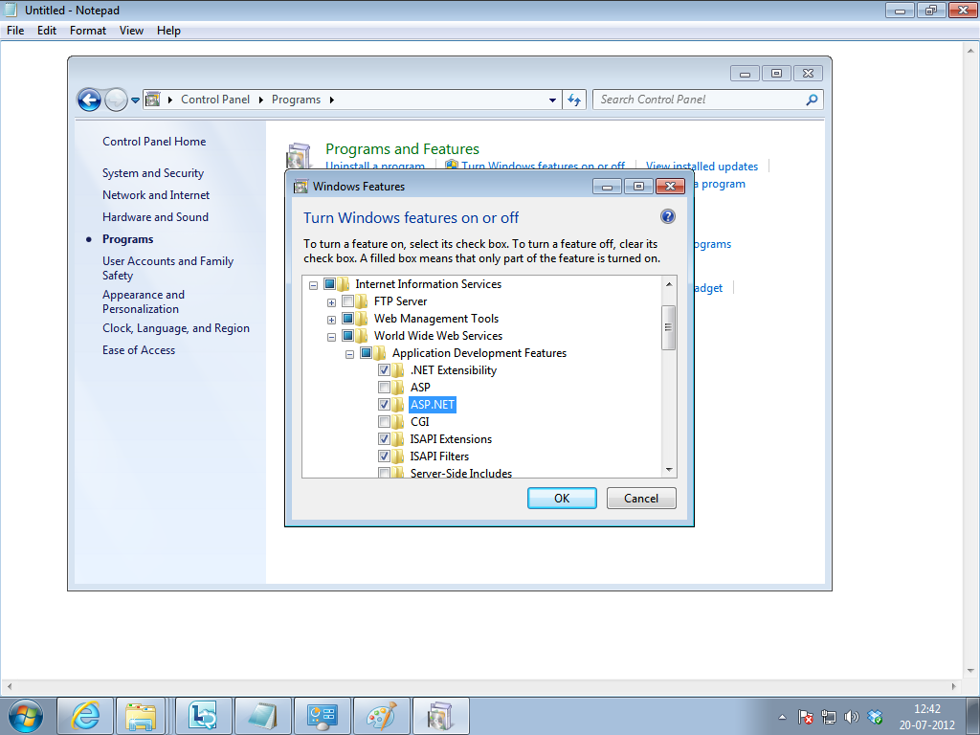

1. Windows would enable these features

# Registering ASP.NET 4.5 with the IIS Web Server

1. Click on **Start**. In the search bar, type **Command Prompt**
2. Right Click on **Command Prompt** and Select **Run as Administrator**
3. Run the following command: **cd <Path>** where Path for
   1. 32-bit machines would be  
      <WindowsDir>\Microsoft.NET\Framework\<version number>\
   2. 64-bit machines would be  
      <WindowsDir\Microsoft.NET\Framework64\<version number>\

For my machine, the command I am running is

**cd C:\Windows\Microsoft.NET\Framework\v4.0.30319**

1. Run the following command **aspnet_regiis.exe -i**

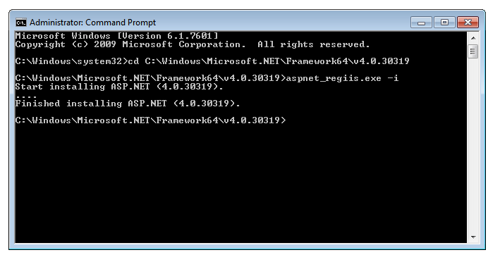

# Building Code

1. Download the code from the project repository.
2. Copy the folder **IVRHierarchies** in Visual Studio **Project** folder. For my machine, the project folder is C:\Users\Aditya\Documents\Visual Studio 2012\Projects
3. Click on **Start** -> **All Programs** -> **Microsoft Visual Studio 2010** -> **Microsoft Visual Studio 2010**
4. Right Click and select **Run as Administrator** and Click **Yes**
5. **Visual Studio 2010** would be launched
6. Click File -> Open ->Project/Solution
7. Select solution file and click **Open.**  All the projects should be loaded correctly
8. Go to **Solution Explorer** -> **IVRHierarchies**. Open **Properties**
9. In **Web** tab, in **Servers** section, click on **Create Virtual Directory**. Press **OK**

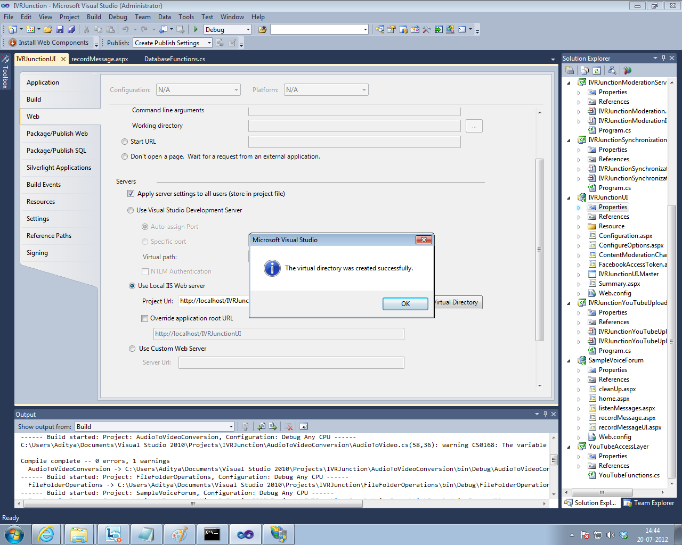

1. Build the Program by pressing **F6** key or by clicking **Build** on Menu bar and then selecting **Build Solution**. There should be no errors.

# Configuring IIS

1. Go to **Start**. Type **inetmgr** in search bar and press **Enter key**
2. On the left pane, Expand **<Desktop-Name>.** Expand **Sites**. Expand **Default Web Site**. You will see **IVRHierarchies** application
3. In **<Desktop-Name>**, Select **Application Pools**. Right click and select **Add Application Pool**
4. Enter **Name** as “**IVRJunctionApplicationPool**”. Select **.NET Framework version** as **.NET Framework v4.XX** from the dropdown list
5. Press **OK**
6. You will see that the **IVRJunctionApplicationPool** is added to the existing list of Application Pools. Right click **IVRJunctionApplicationPool**. Select **Advanced Settings**
7. In **Process Model** section, click on **Identity** row. Click on **button** to change the Identity from ApplicationPoolIdentity to Custom Account
8. In the **Application Pool Identity** window, select **Custom Account** and click **Set**
9. Set **Username** as **DomainName\UserLoginName**. If the computer is not in domain, enter **.\UserLoginName**
10. Set the **Password** as login password of the machine. Enter the same value in **Confirm Password** field
11. Press **OK**. Press **OK** second time. Press **OK** again. You will see that **Identity** column of the IVRJunctionApplicationPool changes from default value to the DomainName\UserLoginName [1]
12. On the left pane, Expand **<Desktop-Name>**. Expand **Sites**. Expand **Default Web Site**. You will see **IVRHierarchies** application
13. Right click on **IVRHierachies**. Go to **Manage Application**. Click on **Advanced Settings**
14. In **Advanced Settings** window, click **Application Pool** row. Click **button** to change the Application Pool
15. In the **Select Application Pool** window, use drop down menu to set **Application Pool** to **IVRJunctionApplicationPool**
16. Click **OK**
17. Go to your browser and type localhost/IVRHierarchies/Start.aspx. If you see no errors then IIS is successfully serving the application

# Configuring Prophecy 13

1. Click on the **Prophecy Tray Icon** in the Toolbars and Select **Prophecy Commander**. You would be directed to the below page

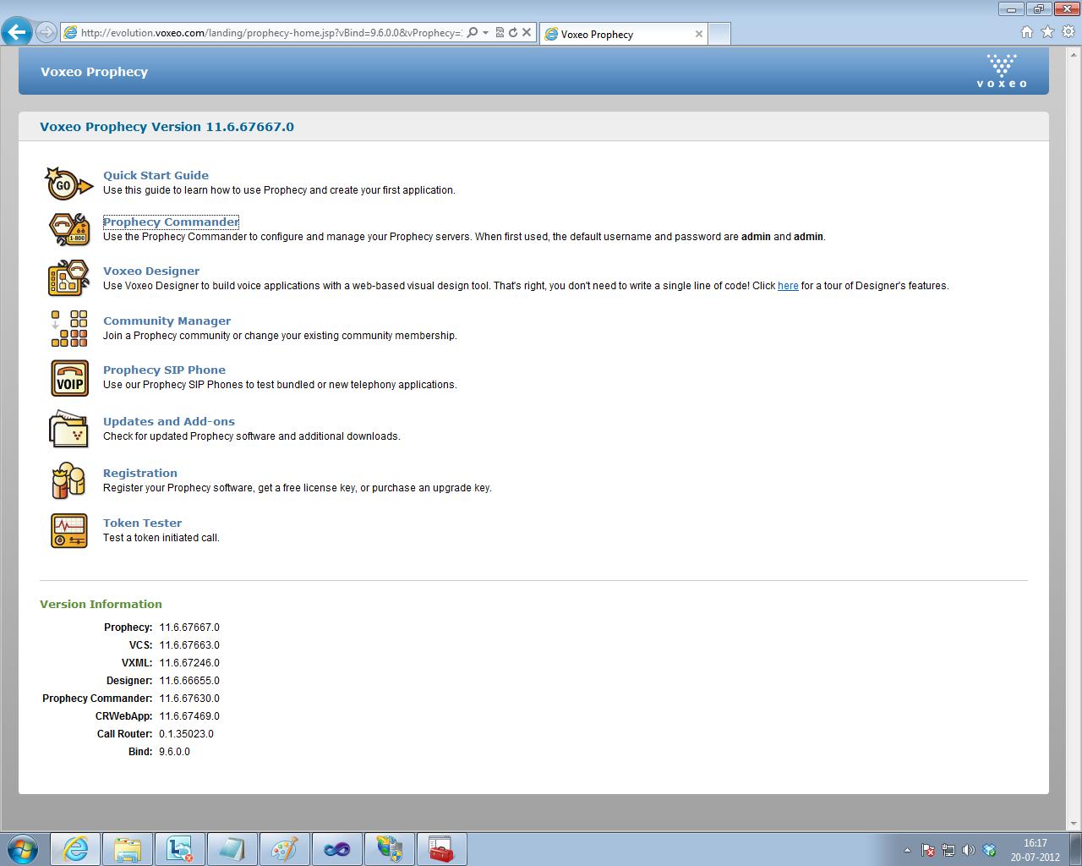

1. Click on **Prophecy Commander**. You would be directed to **Prophecy Management Console**. **Choose password**
2. Click on **New Application**. Enter any name for your application. Change the browser-type for your Application to **VXML**. Click **Next**
3. In **Enter a URL pointing to the location of your application**, enter the URL corresponding to the voice forum. In our case, enter localhost/IVRHierarchies/Start.aspx. Click **Next**
4. Select **Reporting** as **Disabled**
5. Click on **New**. In **New Address** window, enter **Address** value as **ivrexperiment**. Click **OK**
6. Click **Save and Close**. You will see our application added in the existing list of applications

# Quick Checks

1. **All three IVR Junction services must be started**
2. **You must be able to access the URL of the IVR experiment:**

**http://** **localhost/IVRHierarchies/Start.aspx**

1. **All Prophecy services must be running**
2. **Firewall must be disabled**

# Test Call

1. Install Express Talk.
2. Open it and type [ivrexperiment@127.0.0.1](mailto:ivrexperiment@127.0.0.1)
3. Press the green button
4. You will hear the experiment.
5. Press 1 for navigating linear list, Press 2 for navigating shallow hierarchy. Press 3 for navigating the deep hierarchy.

1. **Please note that if you change the login credentials of the machine, you would need update the login credentials by repeating steps 7 to 12.**